JS Applications Exam – the SoftWiki SPA
You are assigned to implement a Web application (SPA) using HTML5, JavaScript, AJAX, REST and JSON with cloud-based backend (Firebase or Kinvey). Using libraries like jQuery, Handlebars and Sammy is allowed but is not obligatory. The app keeps users and articles. Users should be able to register and login. Logged-in users should be able to view all articles, create articles, see details about an article and logout. Logged-in users should also be able to edit or delete the articles they have created. Create a Firebase REST Service
Register at Firebase.com and create application to keep your data in the cloud.
Create a collection called articles. Each article has a title, category, content and creator

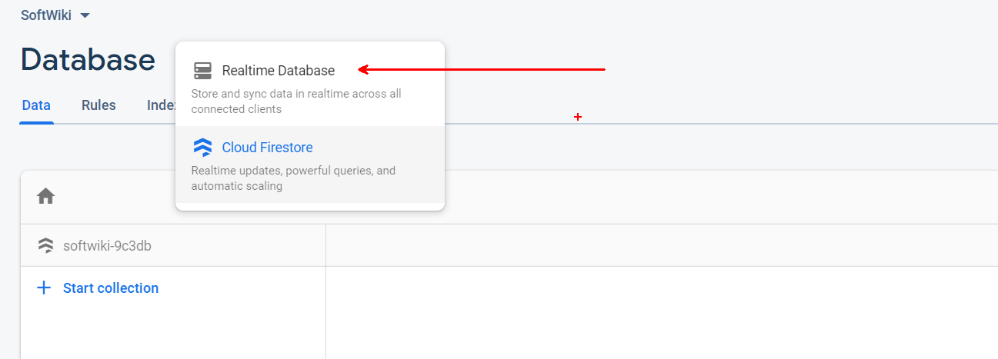
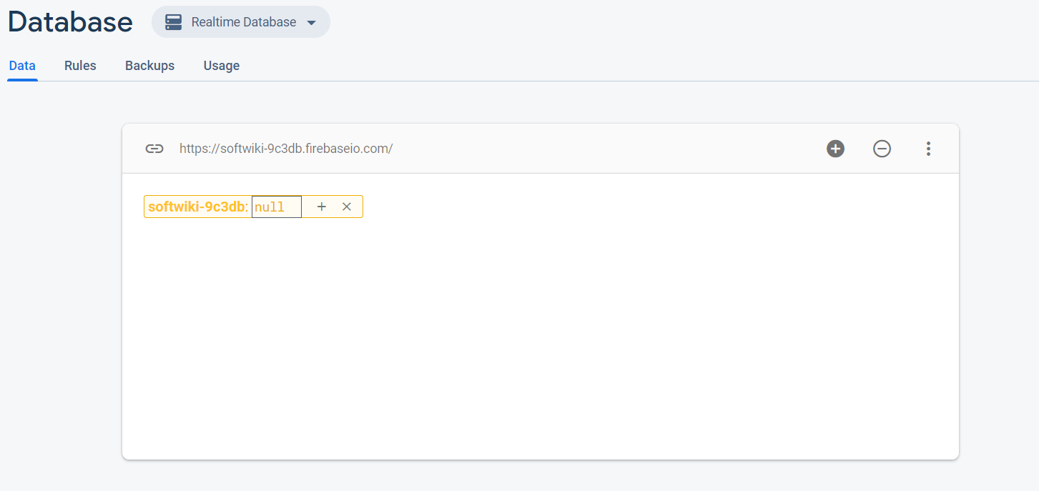
Then go to the rules and edit them to look like this:
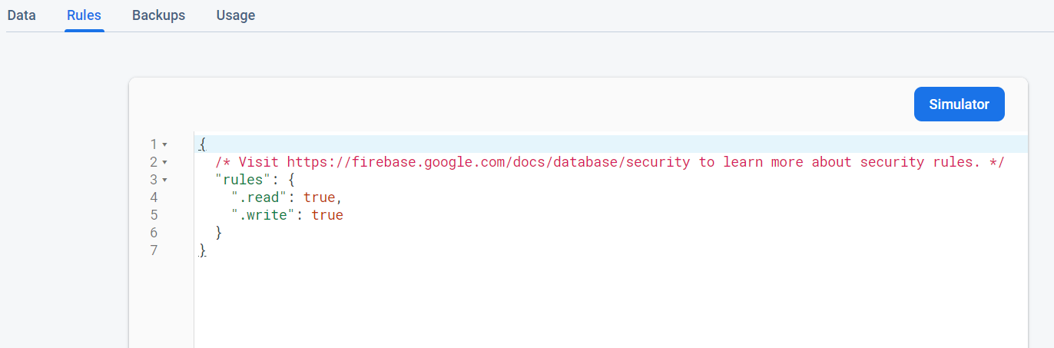

Test the Firebase REST Services
Using Postman or other HTTP client tool, test the REST service end points:

List All Articles
GET https://{apiKey}.com/articles.json

Create Article
POST https://{apiKey}.firebaseio.com/articles.json
Request body | {  "title": "Arrays",  "category": "JavaScript",  "content": "Lorem ipsum dolor sit amet, consectetur...",  "creator-email": "peter.georgiev@email.com"  }
Response  201 Created | {Key}:{  "title": "Arrays",  "category": "JavaScript",  "content": "Lorem ipsum dolor sit amet, consectetur...",  "creator-email": "peter.georgiev@email.com"  }
Error response  401 Unauthorized | { "error": "InvalidCredentials", "description": "Invalid credentials. Please retry your request with correct credentials", "debug": "" }

Edit Article
PUT https://{apiKey}.com/articles/{id}
Request body | {  "title": "Arrays",  "category": "JavaScript",  "content": "Lorem ipsum dolor sit amet, consectetur...",  "creator-email": "peter.georgiev@email.com"  }
Response  200 Ok | {key}:{  "title": "Arrays",  "category": "JavaScript",  "content": "Lorem ipsum dolor sit amet, consectetur...",  "creator-email": "peter.georgiev@email.com"  }
Error response  401 Unauthorized | { "error": "InvalidCredentials", "description": "Invalid credentials. Please retry your request with correct credentials", "debug": "" }

Delete Article
DELETE https://{apiKey}.com/articles/{id}
Error response  404 Not Found | { "error": "EntityNotFound", "description": "This entity not found in the collection", "debug": "" }
Error response  401 Unauthorized | { "error": "InvalidCredentials", "description": "Invalid credentials. Please retry your request with correct credentials", "debug": "" }

The SoftWiki – HTML and CSS
You have been given the web design of the application as HTML + CSS files.
- Initially all views and forms are shown by the HTML. Your application may hide/show elements by CSS (display: none) or delete/reattach from and to the DOM all unneeded elements, or just display the views it needs to display.
- You may render the views/forms/components with JavaScript or Handlebars.
Important: Don’t change the elements’ class names and ids. Don’t rename form fields/link names/ids. You are allowed to add data attributes to any elements. You may modify href attributes of links and add action/method attributes to forms, to allow the use of a routing library.

The SoftWiki- Client-Side Web Application
Design and implement a client-side front-end app (SPA) for managing articles. Implement the functionality described below.

Navigation Bar (5 Pts)
Navigation links should correctly change the current page (view).
- Clicking on the links in the Header should display the view behind the link (views are represented as sections in the HTML code).
- Your application may hide/show elements by CSS (display: none) or delete/reattach from and to the DOM all unneeded elements, or just display the views it needs to display.
The Logged-in user navbar should contain the following elements: [SoftWiki] which is a link to the Home Page, [Create] and [Logout]

- The guest users header should contain the following elements: [SoftWiki] which is a link to the Login page and [Register].

Register User (5 Pts)
By given email and password, the app should register a new user in the system and should redirect you to the home page.
- Keep the user local data in the browser's local/session storage.
Register once and create/read awesome articles!
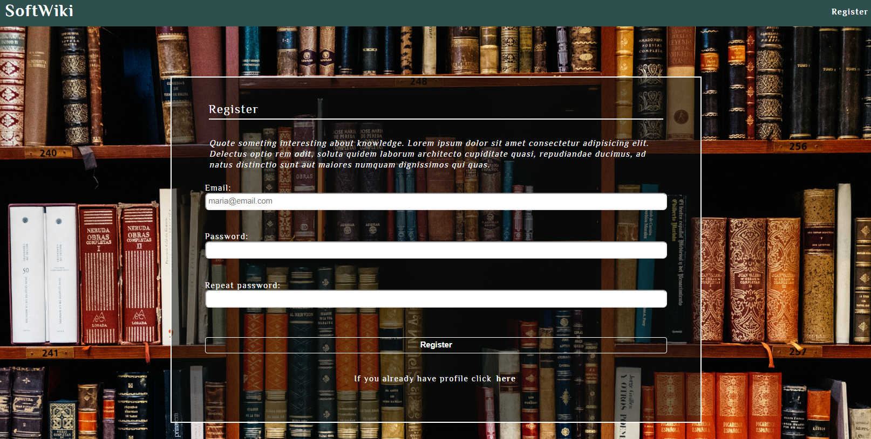

Login User / Guest Home Page(5 Pts)
By given email and password, the app should login an existing user.
- Keep the user local data in the browser's local storage.
- After a successful login redirect to the home page. You are one step away from awesome articles!

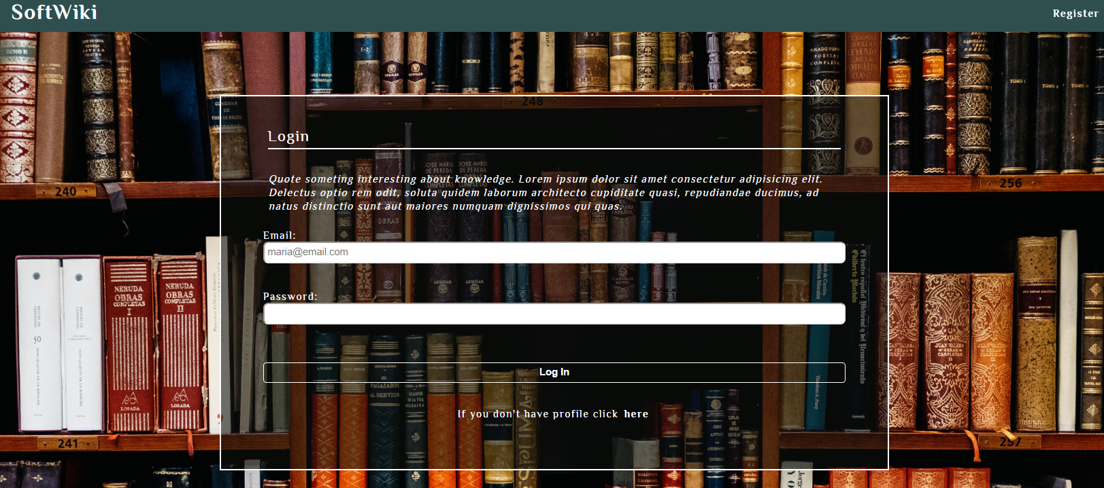

Logout (5 Pts)
Successfully logged in users should be able to logout from the app.
- The "logout" REST service at the back-end must be called at logout
- All local/session information in the browser (user local data) about the current user should be deleted
- After a successful logout redirect to the login page.

Home Page (40 Pts)
Successfully logged-in users should be welcomed by the Home page. They should be able to see all created articles. 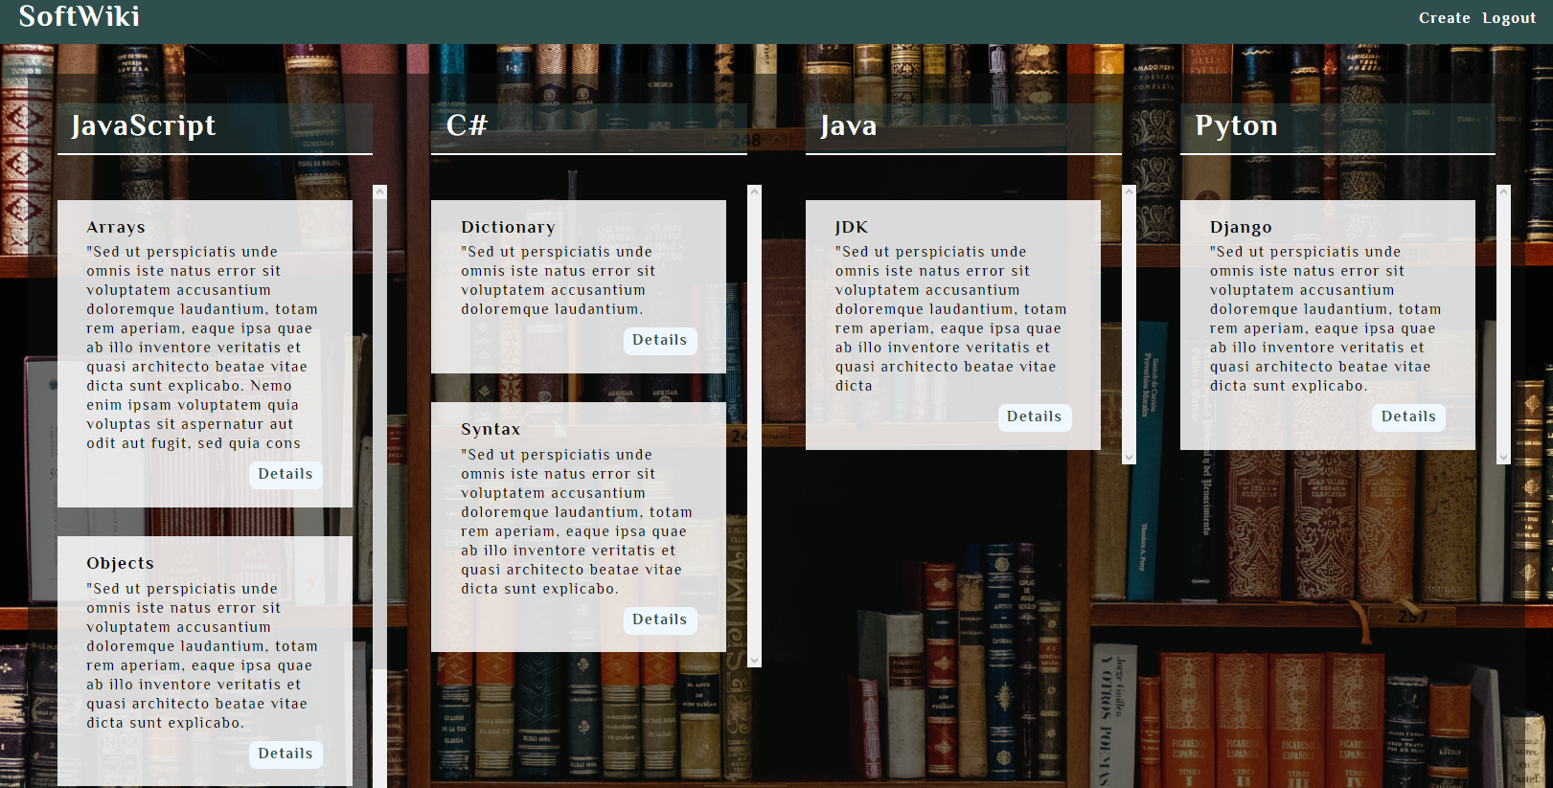

If there are NO such articles, the following view should be displayed:
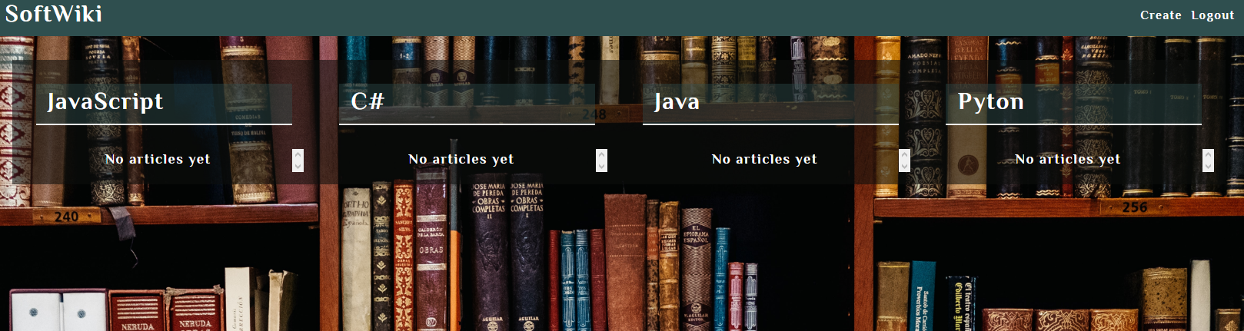

Create Article (10 Pts)
Logged-in users should be able to Create articles.
Clicking the [Create] link in the NavBar should display the Create Article page.
- By default, every newly created article must have additional information:
  - Creator: the email of the current user;
- The newly organizer article should be stored in the Firebase\Kinvey collection "articles".
- After an article is created successfully you should be redirected to the Home Page.

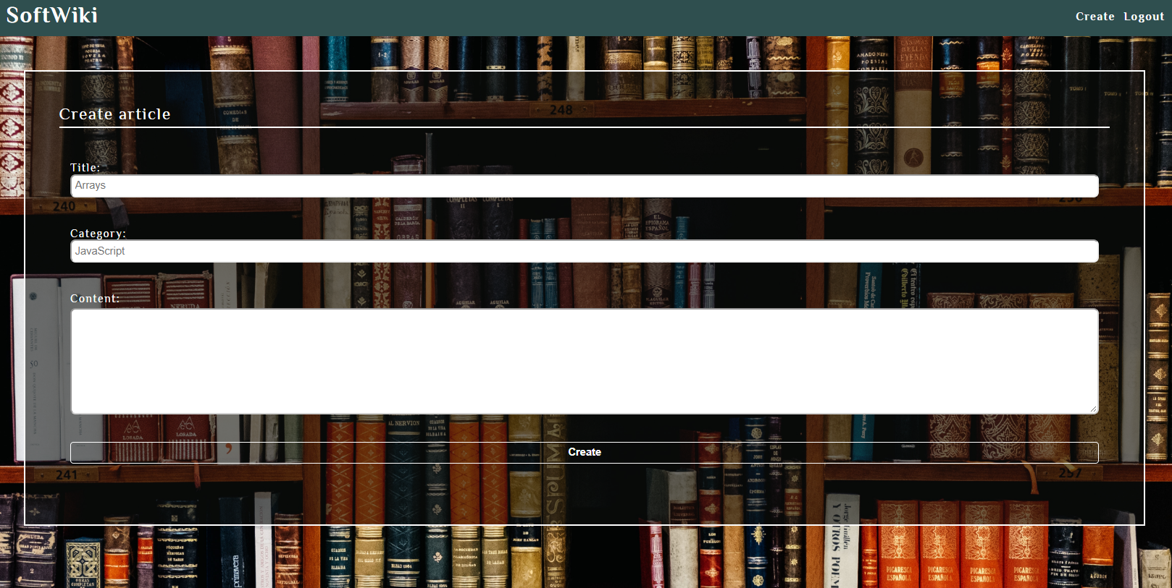

Details (15 Pts)
Logged-in users should be able to view details about articles.
Clicking the [Details] link in of a particular article should display the Article Details page.
- If the currently logged-in user is the creator of the article, the [Edit] and [Delete] buttons should be set to visible, otherwise there should be only 1 button [Back] which redirects to the Home Page.
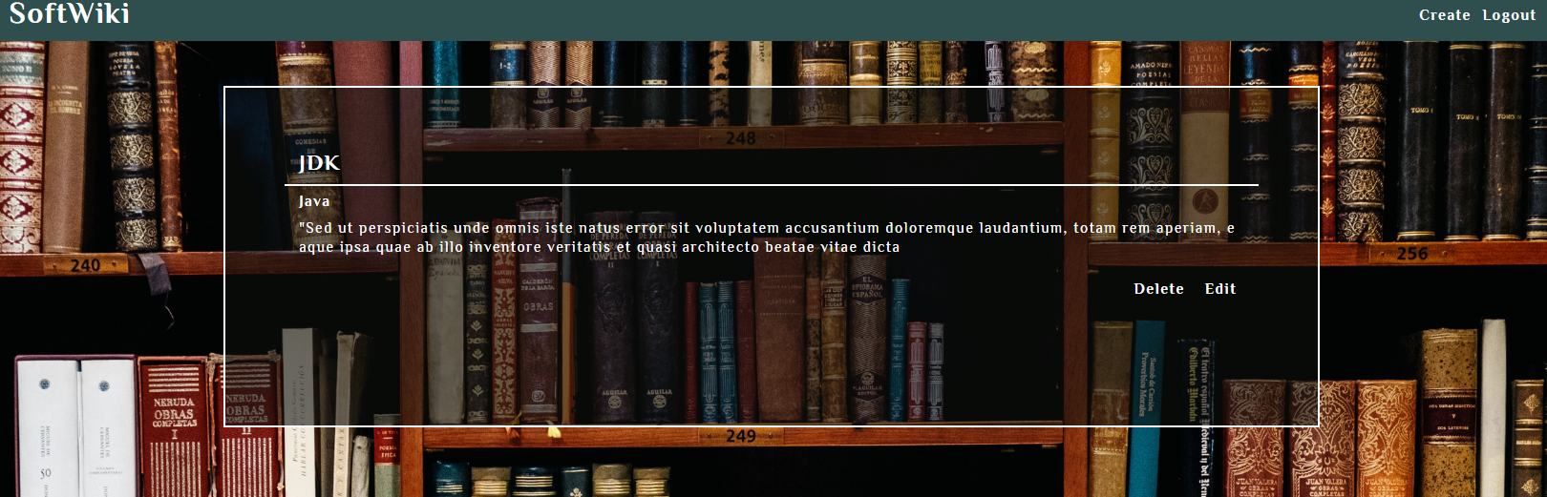
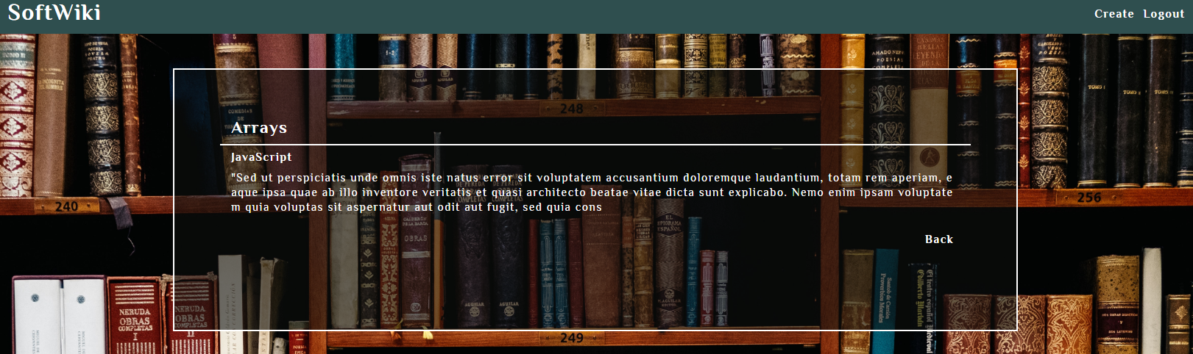

Edit Article (10 Pts)
Logged-in users should be able to edit their own articles.
Clicking the [Edit] link of a particular article on the Details page should display the Edit page:
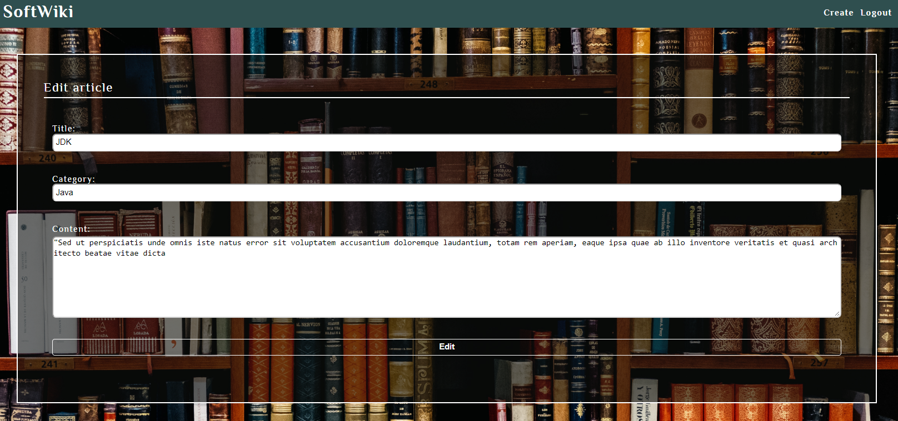
- After a successful edit the user should be redirected to the Home page.

Delete Article (5 Pts)
Logged-in users should be able to delete their articles.
Clicking the [Delete] link of an article (on the Details page) should delete the article.
- After successful article delete you should show the Home page

(BONUS) Sorting: (5 Pts)
The articles in the home page (for registered users), should be sorted in descending order by title.

Submitting Your Solution
Exclude the node_modules folder and ZIP your project. Upload the archive to Judge system.
